Data Collection w/ Macchina P1

Guide

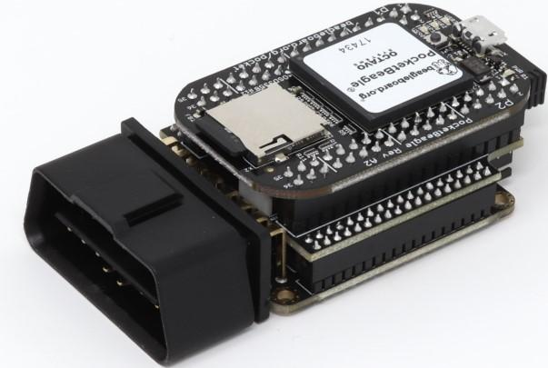

# *TABLE OF CONTENTS*

[***1.*** ***Setup***](https://docs.google.com/document/d/1MUGiZeERxMpiAuOzy3nISXPMdm_WmeOkldovLzzuAX0/edit#heading=h.gjdgxs) ***3***

[***2.*** ***Installation***](https://docs.google.com/document/d/1MUGiZeERxMpiAuOzy3nISXPMdm_WmeOkldovLzzuAX0/edit#heading=h.30j0zll) ***3***

[***3.*** ***Access***](https://docs.google.com/document/d/1MUGiZeERxMpiAuOzy3nISXPMdm_WmeOkldovLzzuAX0/edit#heading=h.1fob9te) ***4***

[***4.*** ***Internet***](https://docs.google.com/document/d/1MUGiZeERxMpiAuOzy3nISXPMdm_WmeOkldovLzzuAX0/edit#heading=h.3znysh7) ***4***

[***5.*** ***Updates & Pins***](https://docs.google.com/document/d/1MUGiZeERxMpiAuOzy3nISXPMdm_WmeOkldovLzzuAX0/edit#heading=h.2et92p0) ***6***

[***6.*** ***Data Capture***](https://docs.google.com/document/d/1MUGiZeERxMpiAuOzy3nISXPMdm_WmeOkldovLzzuAX0/edit#heading=h.1t3h5sf) ***7***

[***7.***](https://docs.google.com/document/d/1MUGiZeERxMpiAuOzy3nISXPMdm_WmeOkldovLzzuAX0/edit#heading=h.17dp8vu) ***Bitrate******8***

***8***[***.***](https://docs.google.com/document/d/1MUGiZeERxMpiAuOzy3nISXPMdm_WmeOkldovLzzuAX0/edit#heading=h.1t3h5sf) ***Python*** ***8***

***9. Data Viewing******10***

**Step One: Setup**

* The macchina p1 consists of two main parts: **Pocket Beagle** and the **Macchina** pictured here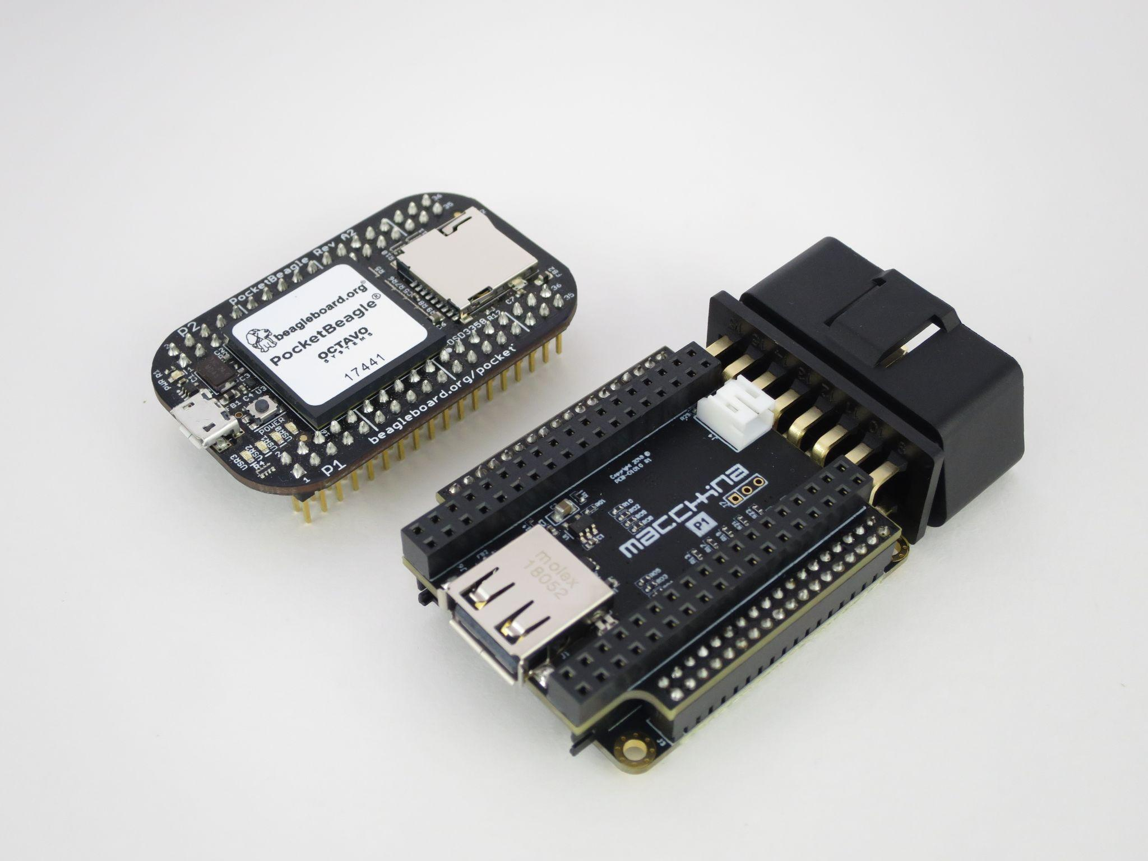
  + The two halves however come put together already saving some initial setup time
  + The Macchina p1 comes with a Wifi dongle and a micro usb along with a sd card
    - The macchina is usb powered
* Proceed by plugging the micro usb into the top half of the Macchina P1 and the wifi dongle into the lower half

**Step Two: Installs**

* After getting everything plugged in a bootable SD card can be created which would then be used by the macchina however macchina comes with a preinstalled image which does suffice for the most part
* However if it is decided to create a new bootable sd card the link below will allow for the latest images to be downloaded
  + <https://beagleboard.org/latest-images>
* A tutorial of how to create the bootable sd drive can be found [here](https://beagleboard.org/getting-started)

**Step Three: Access**

* At this point one should connect to the device for the first time.
  + This can be done either via a preferred terminal or via the web browser
    - There are two options for this 192.168.7.2 & 192.168.6.2
    - 192.168.6.2 should only be used if .7.2 does not allow for connection

Password

* At this point it's possible to change your password
* In order to do this the following commands make this possible
  + ***sudo passwd* root**
    - *\*Note the red is where the user denotes where the user adds their own input*

**Step Four: Internet**

* At this phase, it is necessary to begin connecting to the internet and where issues may begin to arise
* The commands used to connect to begin searching for wifi access points should go as follows:
  + ***sudo connmanctl***
  + ***connmanctl> disable wifi***
  + ***Disabled wifi***
  + ***connmanctl> enable wifi***
  + ***Enabled wifi***
  + ***connmanctl> scan wifi***
  + ***Scan completed for wifi***
  + ***connmanctl> services***
* Upon running these commands a list of available wifi options should be displayed
* Avoid using local or guest wifi options that require an authorization page!
  + As the Macchina will not be able to bypass the page and simply be stuck in a loop
    - If your macchina does find itself in this loop, using a personal hotspot like from a phone will allow it to connect to the internet
  + After deciding on a Wifi to connect to the following commands should be ran
    - **connmanctl> agent on**
    - **connmanctl> connect *wifi_xxxxxx_xxxxxx_managed_psk***
    - **Passphrase? xxxxxxxxxxx**
    - **connected wifi_xxxxxx_xxxxxx_managed_psk**
    - **connmanctl> quit**
  + Running the command **ifconfig** will confirm wifi connectivity
  + If wifi connectivity has failed ssh over to the beagle bone via previously mentioned putty and run the following
    - **sudo connmanctl disable wifi**
    - **sudo connmanctl enable wifi**
    - **iwconfig wlan0**
    - **ifconfig wlan0**

**Step Five: Updates**

* It is crucial that step four has been completed otherwise updates will fail
* The commands for completing the update go as follows
  + **sudo apt update**
  + **sudo apt upgrade**
* In the case of the previously mentioned loop with the Wifi the macchina appears to be updating but several will just fail for no apparent reason
* If this is the case then connecting to a different wifi source and repeating step 4 may be necessary
* The next steps of Step Five will only ever be performed once upon completion
* Verify the following files are available
  + **ls -lt /lib/firmware/PB-CAN0-00A0.dtbo**
  + **ls -la /lib/firmware/PB-CAN1-00A0.dtbo**
    - If one or both of these files don’t exit downloading a new version of the SD drive is necessary
* Next edit the files via nano
  + **sudo nano /boot/uEnv.txt**
* Replace the lines in white with those in red in
  + **#uboot_overlay_addr4=/lib/firmware/<file4>.dtbo → uboot_overlay_addr4=/lib/firmware/PB-CAN0-00A0.dtbo**
  + **#uboot_overlay_addr5=/lib/firmware/<file5>.dtbo → uboot_overlay_addr5=/lib/firmware/PB-CAN1-00A0.dtbo**
* Finally reboot the system
  + **sudo reboot**

**Step Six: Data Capture**

* At this point it becomes time to get the first can data samples this can be done by the following commands
  + **sudo ip link set can0 type can bitrate 250000 listen-only on**
    - Note bitrate will vary vehicle to vehicle
      * The generic bitrate did not work for the vehicle simulator
      * Other suggested bitrates: **500,000 | 125,000 | 33,333**
        + If any of the suggested bitrates work continue through step 6 if not skip ahead to step 7
  + **sudo ifconfig can0 up**
  + **candump -cae can0,0:0,#FFFFFFFF**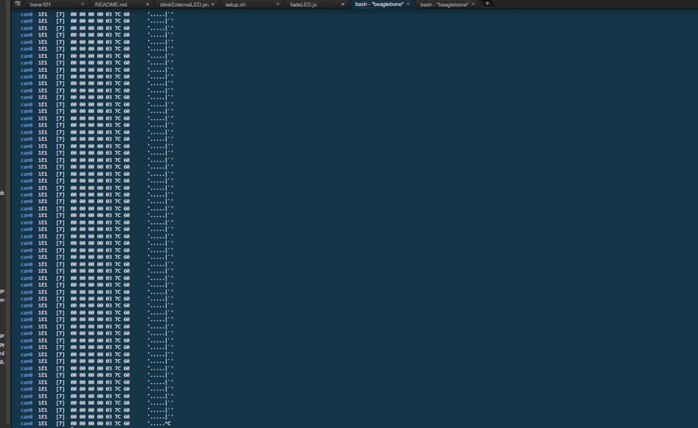
    - An output of the data similar to the picture to the right a constant stream of output
    - If no output is given the image will look similar to the image below consisting of a continuous loading
    - If you find yourself with a continuous loading loop proceed to step 7 if it was successful however please move on to step 8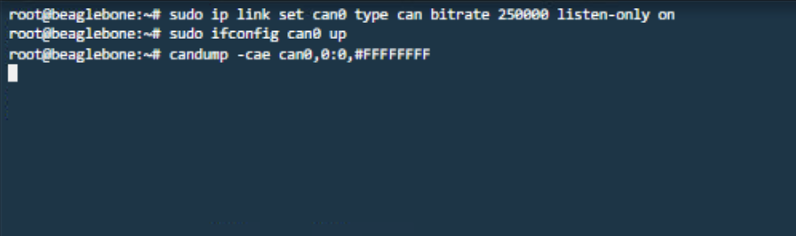

**Step Seven: Bitrate**

* This phase involves utilizing Vehicle Spy the software itself has a free trial version that will suffice as only needs to be used once
* Simply downloading Vehicle Spy trial and loading the software will produce various forms of data automatically as its not bit rate nor can specific in the data it captures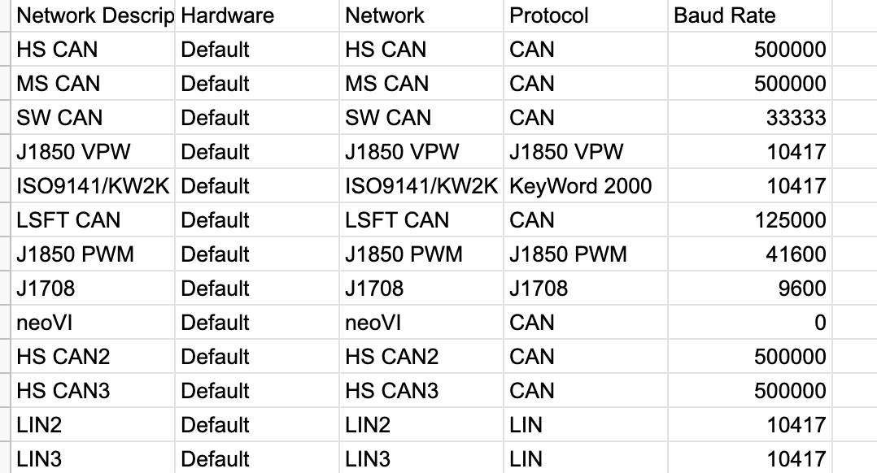
* After a few minutes of capturing outputting the .csv fuzzer file will give a list of varying bitrates an example of the file output is included to the left
  + OBD_Fuzzer_V2A032_12-01-2021_7-37-22_pm.csv
* Other options to discover the baud rate of your personal vehicle include actually calling your car manufacture about the baud rate/bitrate of your vehicle make and model

**Step Eight: Python**

* To begin download the following file via the command below into putty or the terminal
  + **wget -P ~/scripts** [**https://gist.githubusercontent.com/kenny-macchina/cf47daf663f9091460fc3454f5e38de9/raw/676f2a36f300fa8e5c9c43c05a7bc18af2479b5c/p1_data.py**](https://gist.githubusercontent.com/kenny-macchina/cf47daf663f9091460fc3454f5e38de9/raw/676f2a36f300fa8e5c9c43c05a7bc18af2479b5c/p1_data.py)
* After grabbing the package installing the package is the next step however without updating python the install will fail if python is not up to version 3
  + To check version of python
    - **python –version**
  + To update python run the following
    - **sudo apt update**
    - **sudo apt install python3.9**
      * *Replace 3.9 with whatever version python is currently on
* After performing the update you can now begin the install of the previously grabbed script
  + **curl https://bootstrap.pypa.io/get-pip.py -o get-pip.py**
  + **python get-pip.py**
  + **sudo reboot now**
* Upon successful completion being installing the pip package with the following commands
  + **curl https://bootstrap.pypa.io/get-pip.py -o get-pip.py**
  + **python get-pip.py**
  + **sudo reboot now**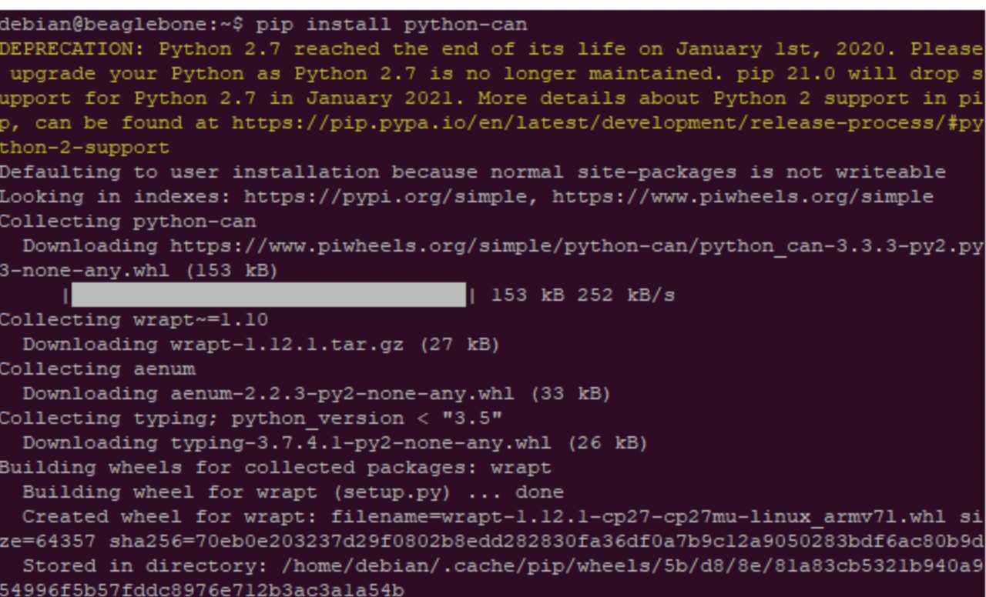
* Finally install the CAN library which will allow for the data to be analyzed and converted into a csv file
  + **pip install python-can**
  + **sudo reboot now**

**Step Nine: Viewing the Data**

* With python set up the user can once again begin collecting data this time utilizing the python script in the home directory run the following: 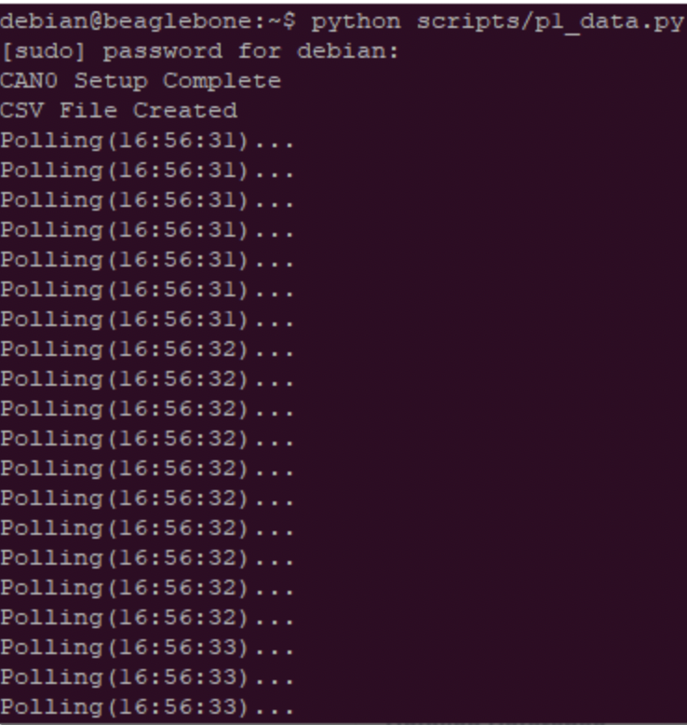
  + **python scripts/p1_data.py**
    - The image left shows a successful output
  + **python3 -m http.server 1337**
    - The second command outputs the csv file and its data in a server that can then be more easily viewed an example of this is shown below